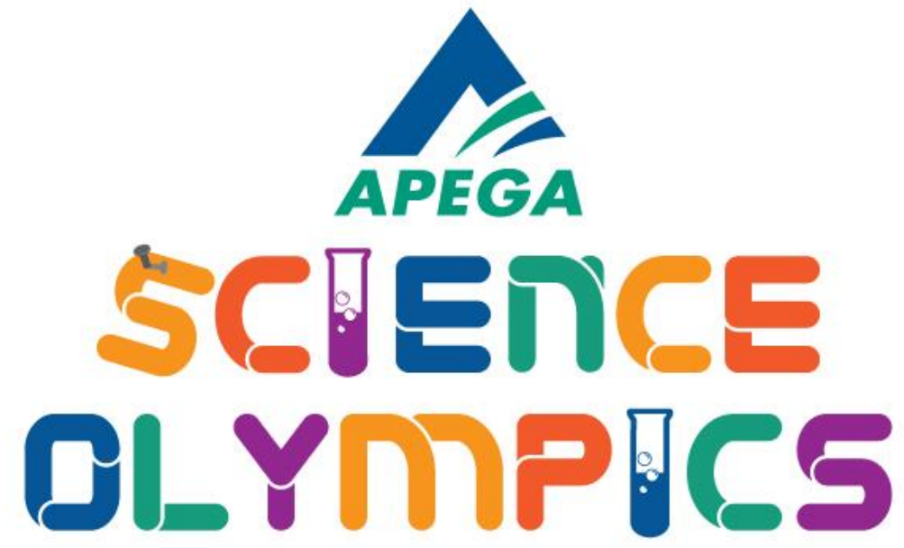

“The Potato Bagger” by Crestwood Division 3 Grade 9 team – Project Documents

Table of Contents

Summary
Proudly representing our school, we, the ninth grade team of Crestwood, present our prototype of the 2022 APEGA Science Olympics challenge: "The Potato Bagger".

Aptly named in literal sense to its construction, the potato bagger is a fully functional stretcher with focus to simplicity and light-weightedness made almost completely from reused materials. It's layer of reused plastic grocery bags, thick and strong, is capable of holding more than 10 pounds, along with cardstock bars for a sturdy, balanced handle to transport the patient.

Affordable and ecological, the potato bagger can save lives while taking plastic out of landfills. As previously noted, the potato bagger is built from reused cardstock and plastic grocery bags costing little to nothing along with common materials such as glue and duct tape that is redilly available.

Budget Sheet
Material | Cost of Material
Hard board | $0
Grocery bags | $0
Packaging ribbon | $0
Pink paint | $0
Duct tape | $0
Construction Glue | $10.87

Materials: $0.00
Adhesive: $10.87

4(0) + 10.87 = 10.87

Engineering Design and Process Chart
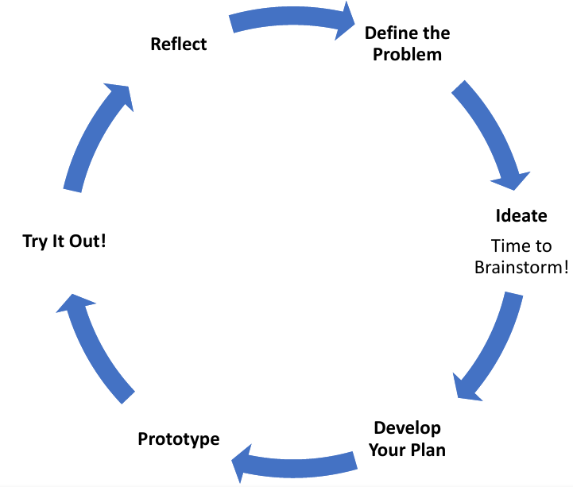
Steps in the Engineering Design Process | How we completed the Steps
Define the Problem  What are you trying to solve? | We need a stretcher-like device sturdy enough to hold 10lbs over a fairly large area. It must:  1.Be mostly or completely recycled (this also avoids pre-assembled pieces)  2.Stiff and sturdy to hold well over 10 lbs  3.In some way extendable to comfortably hold any potatoes/injured hikers while meeting the size limitations  4.quick to assemble/deploy
Ideate  What are possible solutions to your problem? Generate as many ideas as possible! | 1.We checked for any materials we already had in our houses. We all agreed that if possible, no shopping should have to be done to maximize our score in this regard  2.All the sample designs we had consisted mainly of a stiff material for a frame, and a high tensile strength fabric, so if both are found, we have a strong stretcher.  3.we came to deciding between a telescopically extendable design, or a foldable design. In the end, we decided that folding would be more consistent and sturdier  4.The design should be in one piece to be incredibly fast to use
Develop Your Plan  Select one idea to move forward with. What steps will you take to make this idea a reality?  Include the details of your plan in your blueprint below | We decided on a four piece folding design  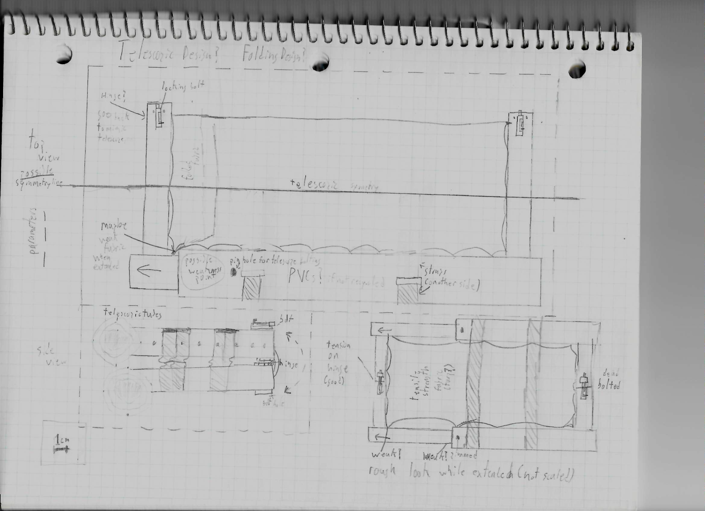  This is planned to be one corner of the design, it will fold out like a book twice. The hinges were planned to be cloth. We created a 1:2 scale cardboard prototype to concept it  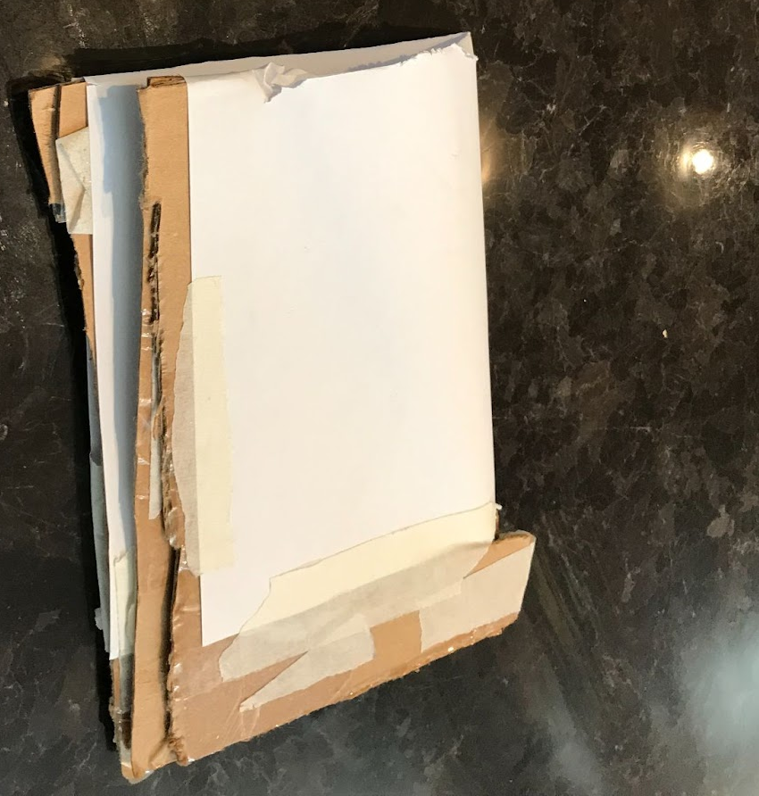  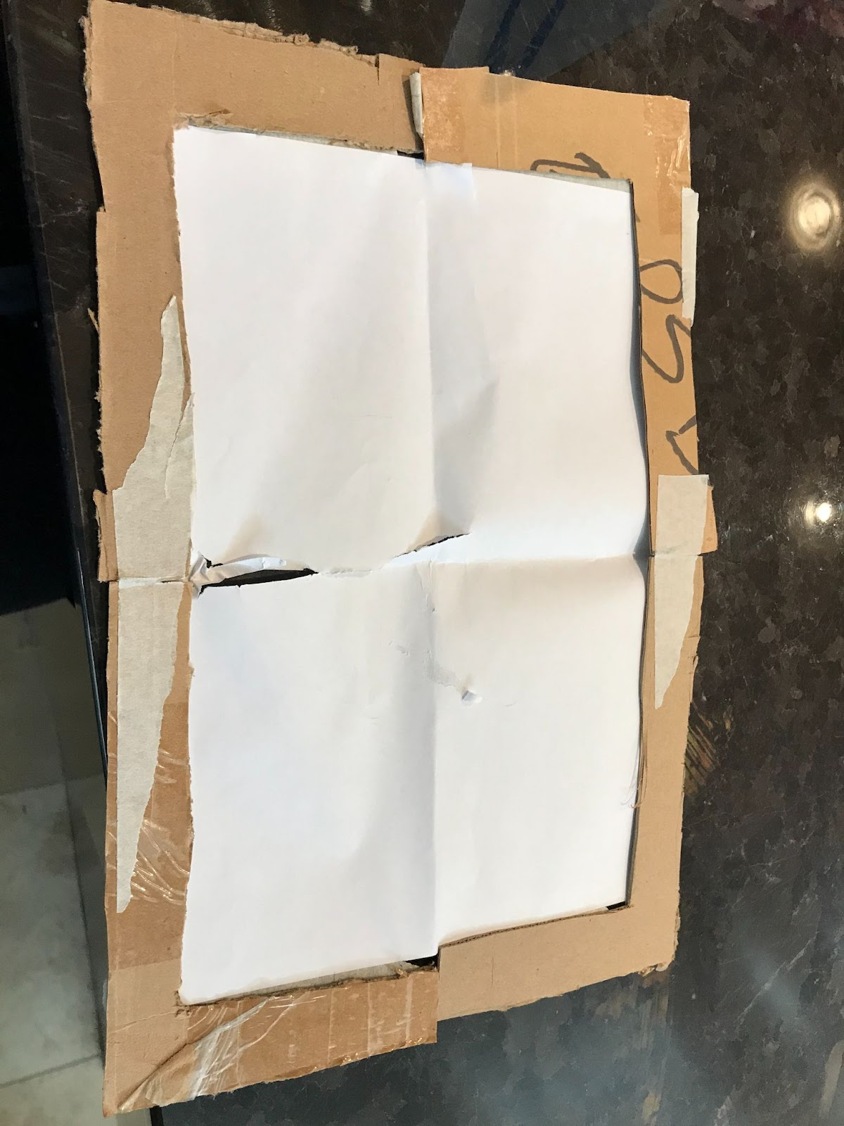  We found pulp board as the best material for the frame, and the decided plastic grocery bags would be perfect as the cot material
Prototype  Create your model.  Did you encounter any problems or have to change your design at any point? | The pulp board was not strong enough, so we had to double layer the strips.  The original plan for hinges were not sturdy enough so they were adapted.  After the previous two changes, we were risking the compactness of the project. After also seeing how well grocery bags worked, there was a revamp: the design loses some of the frame and is turned into a sort of bag. Because the new design trappen in the potatoes, straps could be omitted from the design.  (There was a time where the missing frame was separated to be assembled, but due to project time constraints, assembly time constraints and packing complexity, they were too difficult to implement)
Try It Out!  Test your design. Does it perform the way your expected? | The design holds 10lbs beautifully. It could even support someone leaning on it. It holds itself together incredibly;it can be reused consistently and shows little sign of wear. All tests were done well and effectively.  Plastic bags are surprisingly comfortable!
Reflect  Is there anything you can do to improve your design? | - We could have perhaps leaned fully into the body-bag sort of hold by extending the grocery bags to encapsulate more.  - Perhaps more can be done about its visual appeal

Blueprint
